6.31: Use the Work-Energy Theorem and the results of Problem 6.30.
a) 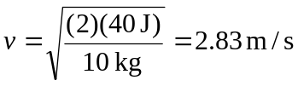
b) At 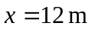, the 40 Joules of kinetic energy will have been increased by 20 J, so 

